**TASK-11**

Palindrome

**EXPLANATION:**

The program asks the user to enter to enter a number. The program then reverses the number and if the number is palindrome, the program displays that the number is palindrome otherwise the number is not a palindrome. If user enters a character, the program displays the error message and returns the user to again ask the number.

**INPUT:**

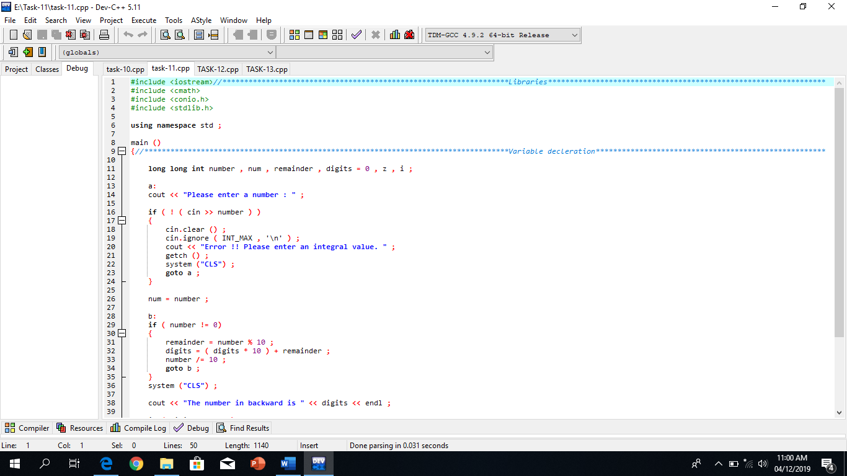

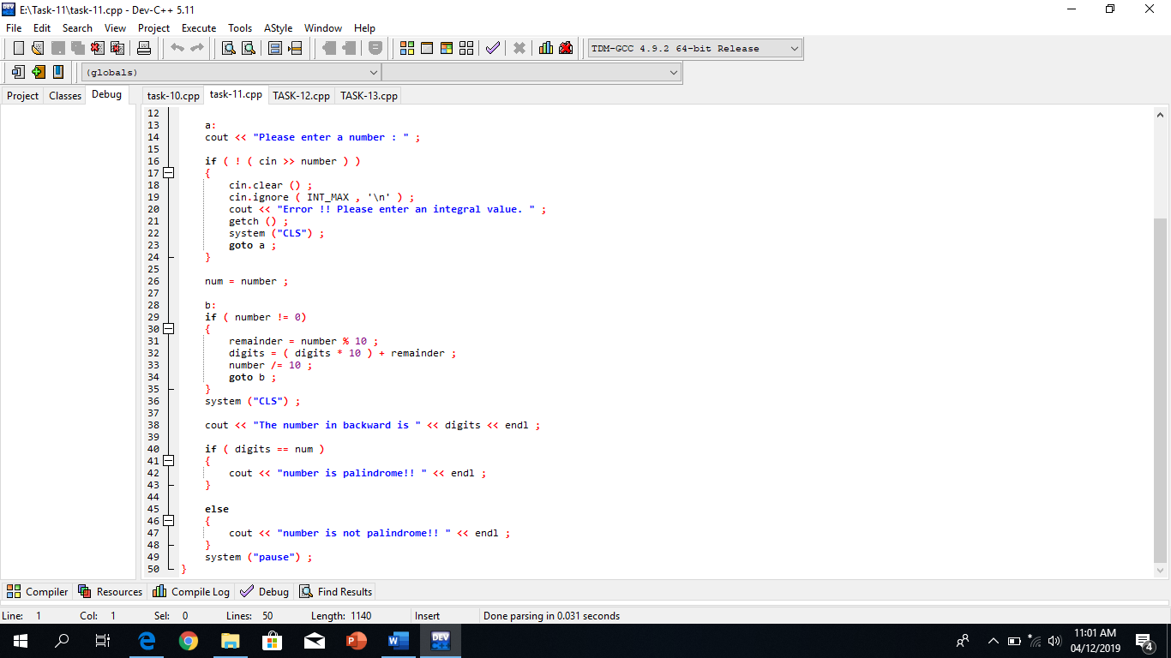

**OUTPUT:**

